**CASE STUDIES OF PUBLIC RELATIONS**



**Submitted To:**

Faiza Abid

**Submitted By:**

ZAINAB AGHA (36)

MS MASS COMMUNICATION

2019-2021

**DEPARTMENT OF MASS COMMUNICATION**

**LAHORE COLLEGE FOR WOMEN UNIVERSITY**

**Public Relations Case Studies**

1. **Gitlab’s Data Crisis:**

**Issue:**

On January 31, 2017, one of Gitlab’s software developers accidentally removed client's’ data from the primary database server. In addition, several backup attempts didn't work and the company lost access to a huge amount of data. Gitlab.com’s service was not available for 18 hours, which was unacceptable for the company. Just to stress the gravity of the issue, Gitlab’s clients are such companies as IBM, Sony, NASA, Alibaba, Invincea, Jülich Research Center, O’Reilly Media, Leibniz-Rechenzentrum (LRZ) and CERN, and it was their code that Gitlab accidentally deleted. The crisis started the moment Gitlab announced the issue through the social media.



**How did they manage the crisis?**

Gitlab announced to their clients and their social media audience that the issue had occurred. Next, they gave a detailed explanation and told what happened and how they planned to fix it. A couple of days after the incident was solved they published the detailed explanation with the lessons they learned.

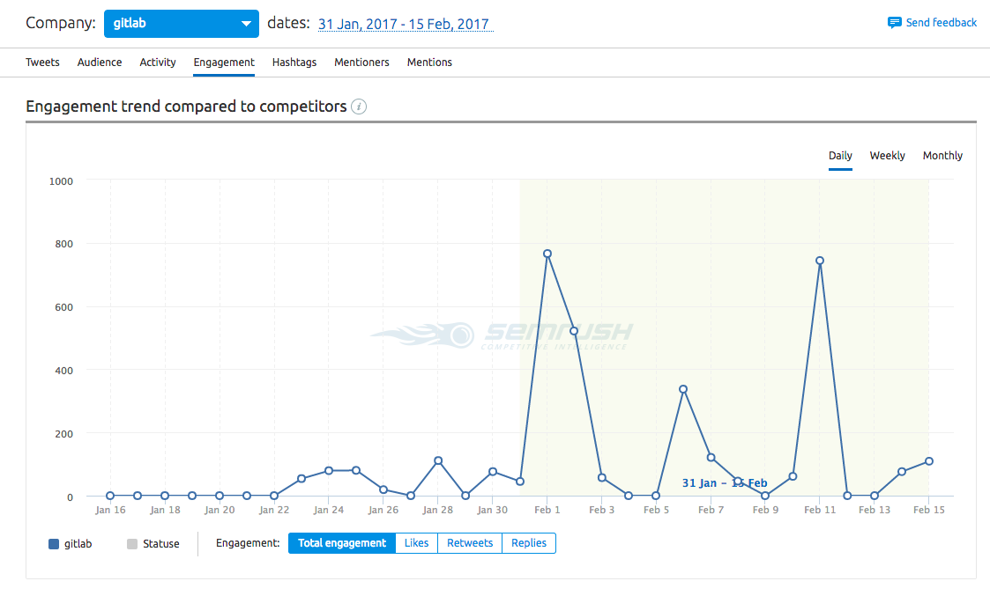

There are two spikes - the increase of reaction to the tweets. These two tweets with detailed explanation got the most engagement throw all the crisis period.

The issue was serious, and it couldn’t be fixed fast, so Gitlab did an interesting thing - they asked the professional community for help. They restored access to the data in a live format, so everyone could participate and help. Another bonus, they made communication easy:

* They made a Google Doc with live notes.
* They created the hashtag #HugOps to cover social media.
* They live-streamed on YouTube to discuss the problem-solving process.

Gitlab created a large-scale discussion and welcomed everyone to the online event.

**Conclusion:**

Gitlab’s issue was no longer a crisis but a challenge for the entire professional community, and those professionals were glad to help. The issue was solved.

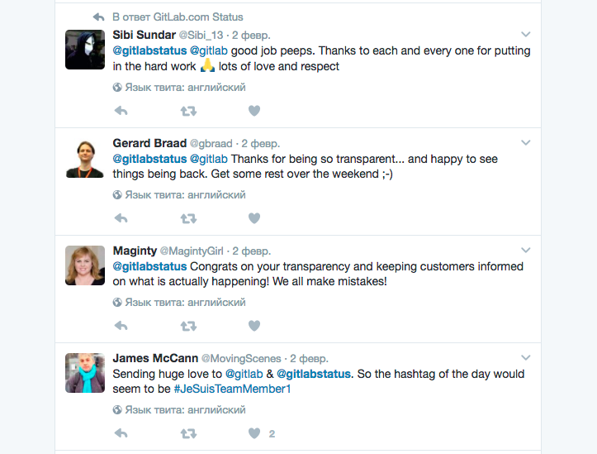

1. **Corruption scam involving bank executives. Payment of kickbacks. Graft. Diversion of funds. Money Laundering**

**Client.** Major British Bank (MBB) owned 50% of Brazilian Investment Bank (BIB). MBB had management responsibility for BIB and was responsible to other shareholders.

[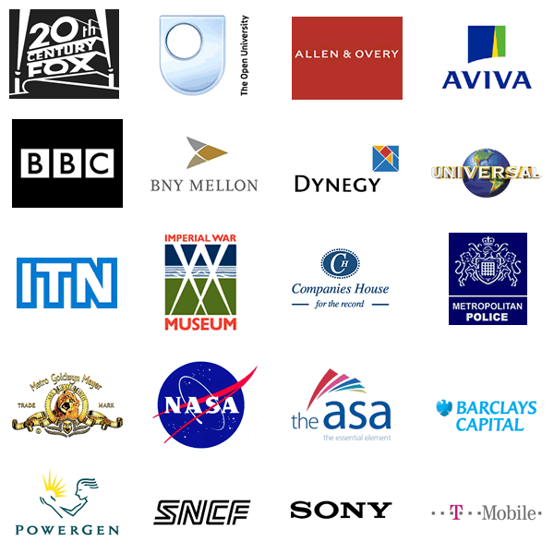](https://www.google.com.pk/url?sa=i&url=https%3A%2F%2Flogodix.com%2Fbritish-bank&psig=AOvVaw0q3p-3MaSCti_nbB5maP1k&ust=1581359645645000&source=images&cd=vfe&ved=0CAIQjRxqFwoTCIj4sPeOxecCFQAAAAAdAAAAABAD)

[](https://www.google.com.pk/url?sa=i&url=http%3A%2F%2Fbraziliangringo.com%2Fopen-brazilian-bank-account%2F&psig=AOvVaw1-UPJjQ028_q9JNuuideDH&ust=1581359725146000&source=images&cd=vfe&ved=0CAIQjRxqFwoTCKCS8qaOxecCFQAAAAAdAAAAABAD)

**Problem.**

Workout team from MBB’s head office discovered that the entire capital of the Brazilian bank (US$500 million) had disappeared in in bad loans. In addition to the potential reputational damage, MBB was responsible to the other shareholders.  
Prior to the arrival of the workout team, an expatriate adjunct-director had denounced the kickback scam. His warnings were ignored.

**Solution.**

Investigation revealed an organized scam involving loans to non-creditworthy borrowers with kickbacks to bank management. BIB was also laundering drug money and money for corrupt politicians. The adjunct- irector who denounced kickback scam was being set up as a scapegoat to divert attention from the fact that corporate management had consistently ignored warnings, to the extent of dismissing the previous expatriate director who had attempted to bring the matter to their attention. A credit recovery strategy was implemented and reputation damage control exercise was carried out.

1. **The Volkswagen emissions scandal**

**The scandal**

[](https://www.google.com.pk/url?sa=i&url=https%3A%2F%2Fwww.marketwatch.com%2Fstory%2Fvolkswagens-pr-response-made-problems-worse-experts-say-2015-09-25&psig=AOvVaw1UkIZs58cs1usEloQ3SZ29&ust=1581361821305000&source=images&cd=vfe&ved=0CAIQjRxqFwoTCLDD8ISWxecCFQAAAAAdAAAAABAD)

In 2005, VW CEO Wolfgang Bernhard wanted to reaffirm VW’s position in the world’s most competitive market—the United States. He believed that diesel engines were the gateway to compete with VW’s Japanese rival, Toyota Motor Corporation, and to capture the U.S. market, which had stricter environmental standards. Rudolf Krebs, an experienced engineer from Audi whose prototype had worked well in South Africa, recommended the additional use of AdBlue in the planned engine, which was later named EA 189. When Bernhard left and Krebs was transferred to another position, Martin Winterkorn became CEO in 2007. After taking office, Winterkorn instructed Ulrich Hackenberg and Wolfgang Hatz, key Audi team members, to expedite the engine development.

In 2007, VW introduced the diesel engine EA 189, which efficiently met tighter emissions controls and better fuel efficiency standards. EA 189 became an effective differentiator, which increased VW’s U.S. market share. The increased clean diesel sales volume in the United States, which rose from 43,869 in 2009 to 98,500 in 2014, reflected the high customer acknowledgment. VW positioned the innovation with the “clean diesel” mantra. Its aggressive promotion campaign claimed the following:

In 2012–2013, various environmental organizations raised concerns that diesel cars were not as clean as claimed. In 2013, an environmental association, DUH (Deutsche Umwelthilfe), revealed audit reports highlighting significant irregularities between the test mode and the actual driving mode in Germany. The reason for VW’s exceptional diesel performance was unveiled when the International Council on Clean Transportation conducted similar tests in the United States and informed the EPA and the California Air Resources Board about several VW brands and models that failed the tests.

After a series of investigations, VW admitted that it used a defeat device to improve performance and eventually change buyers’ perception regarding diesel technology. VW’s acknowledgment of manipulation led to several countries launching investigations and many customers filing lawsuits. VW then started a recall in January 2016, which was expected to last until the end of the year.

**Strategies:**

The scam not only put VW’s reputation at stake, but it also put the entire diesel industry under scrutiny. Mike Hawes, CEO of the Society of Motor Manufacturers and Traders, agreed that the emissions scandal had damaged the reputation of the entire industry and that it was now on the industry to rebuild customer faith.40 Andy Palmer, chief executive officer of Aston Martin, said that this scandal would make customers not only wary of all new VW cars, but that they would also doubt other car makers for some time. He predicted that the diesel engine would die a slow death. The only way the auto industry could recover was to phase out diesel engines.

Suppliers, too, felt diesel technology had taken a big hit. According to Akshay Anand, a senior analyst at Kelley Blue Book, suppliers would do better to seek out and adopt other technologies until customer trust in diesel was regained, which could take a long time. He felt that it would depend on suppliers and how much of their production was diesel. Despite the scandal, the global auto industry’s dilemma remained the same: providing greater mileage with lesser emissions—but ethically, without manipulation.

**Results:**

By giving statements the scandal was handled nicely.

1. **Tylenol Case**

Tylenol represented 37% of the analgesics market, with sales exceeding 500 million dollars. With or without precedent, any crisis can be a tragedy or an opportunity. Johnson & Johnson turned it into a triumph. This is the evolution of the crisis and how they controlled it, as described by specialty works (Bobstock P., 1985, S. Fink, 1986, MK Pinsdorf, 1987)

**Events evolution**

In the year 1982, for reasons still unknown, one or more strangers, replaced Extra Strength Tylenol capsules, well-known analgesic drugs with poisonous capsules containing cyanide. Poisonous pills have been stored on the shelves of more than half of the pharmacies or supermarkets on the city of Chicago. Accordingly, poisoned pills were bought, and 7 people died in terrible pain. Thus, on 30 September 1982, Jim Murray, a member of staff of public relations, went into the PR office, to tell about a bizarre phone, received from a reporter from the Chicago Tribune newspaper. The reporter told him that he was in the middle of an investigation, during which he had somehow made the link between Tylenol and death of a person. In a first phase, the president of the company charged the Executive Director to discover what was happening (crisis identification action, its isolating, a team creation), he was personally involved by collecting facts, he designated public relations specialist to manage the situation and established a permanent communication with the team. Another important measure was to call a lawyer who he knew very well asking him to obtain information from [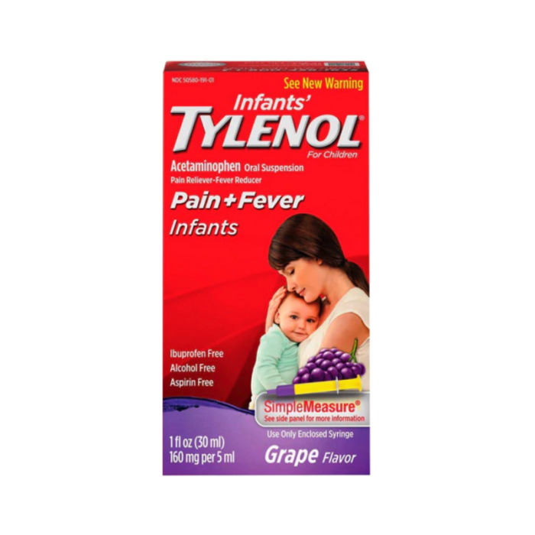](https://www.google.com.pk/url?sa=i&url=https%3A%2F%2Ftopclassactions.com%2Flawsuit-settlements%2Fconsumer-products%2Fbaby-products%2Fjohnson-johnson-infants-tylenol-class-action-settlement%2F&psig=AOvVaw2aJ73RzElL8MAfNplYNE79&ust=1581369614054000&source=images&cd=vfe&ved=0CAIQjRxqFwoTCJDo6YmzxecCFQAAAAAdAAAAABAJ)the hospital, from the police, from every possible source.

The first three priorities he established in an attempt to limit the disaster were: - stopping the loss of lifes, - discovering the causes of death - aid all those in difficulty. He thought that the main cause of death could be located within the company. If it was indeed so, he could discover exactly if it is about a technical installation that has not worked properly, an employee who had made a huge mistake or an intentional sabotage. Once discovered the cause, thus identified the source of the crisis, things could be stopped. Several days later, after a thorough analysis of the above, it was very clear to business leaders that there was no internal reason in triggering the crisis. In addition, after a series of other internal investigations, required by the authorities, they realized that the issue is of the competence of the FBI and Chicago police. During this time, the entire management team of the company was in alert: while wishing that people no longer die, they found that there had not the slightest information about the causes of these accidents. The crisis seemed out of control.

**Strategy of crisis management**

The company response was based on several types of actions:

a) warning consumers across the U.S. through the media,

b) stop the production of Tylenol capsules and advertising for these products,

c) establishing connections with the police, FBI, local authorities, etc.

d) withdrawing capsules from the market;

e) designing and producing another type of packaging, more resistant (50 million dollars have been invested in this action)

f) re-introduction of new products on the market, through a marketing effort.

Immediately, the production of vials was stopped and all incriminated products were withdrawn from the market (their value was of 100 million dollars). Moreover, the customers could change Vials concerned with other products of the firm. In total 31 million bottles were collected, out of them 8 million capsules were verified. Only in 75 of the capsules the cyanide was found. Subsequently, the company has donated 50 million capsules to doctors across the country. Research on public attitudes showed that after one week of the start of the crisis, 90% of the population knew that the company is not guilty, and 35% of those who currently used Tylenol had confidence in this product. Until it was clear that technical installations were correct and there were no problems with the employees work, Collins has not acted. The good news came when it was officially confirmed that the possibility that poison had been introduced from within the company was near zero. The bad news was that a psychopath came in many pharmacies and stores in Chicago and, using the packaging and Tylenol capsules, had introduced cyanide and made so that the difference between normal and poisoned not to be perceived. As soon as it became clear that Johnson & Johnson is the victim of an external sabotage, things have evolved differently. The real issue became the rescue of Tylenol and the rehabilitation of the company.

**Communication with involved publics**

Communication strategy was based on the following directions:

• Internal and external information of all concerned publics;

• talking those publics into supporting the company and support its actions;

• Publics training in order to implement the actions envisaged by the company.

Out of the involved publics, the most important were: consumers, pharmacists, managers and employees of the super market chains, doctors and hospitals administration, the authorities involved in drug control, the FBI, the police, the press (general and specialized). The communication strategy was based on information openness and cooperation with involved officials. Checking all information has also been an asset to the press, especially the information that the company has sent up have proven to be true. The further evaluation of about how the acute phase of the crisis was managed has highlighted three crucial aspects in this success: the opening to press, pay all costs related to product withdrawal, fair play of the press and public, who granted the presumption of innocence until the proof to the contrary. During the crisis around 80,000 news stories appeared in newspapers in the U.S., several thousand in local and national television and radio. More than 90% of Americans were aware of the scandal related to Tylenol capsules, in less than a week of crisis. An editorialist even called this information flow as one of the most important after the Vietnam war. The company has organized more than 30 press conferences, often transmitted directly to national scale; also the headquarters in New York were the host of numerous teleconferences, broadcast in major U.S. cities The company carried out an advertising campaign in central newspapers, by which the consumers were notified of the replacement of capsules by tablets. This solution was considered a success. On November 11, more than a month after the start of the crisis, the company has held a teleconference, during which it launched new packaging, and the information was taken by all the American press.

To resolve the crisis of communication, especially with consumers, Johnson & Johnson has taken the following:

• has launched a video advertising of 1 minute, which was mostly conducted in October and November. The message The message was sent by Dr. Thomas Gates, medical director of the McNeil Consumer Products Company, who announced the consumer about the imminent return of Tylenol on the market. 85% of Americans have seen the video at least 2 times during the first week of its broadcast;

• the directors have appeared in the press in issues of large audience, to give information about the company

• the employees were kept informed at all times through four videos;

• at the top of the crisis over 400.000 e-mail messages were forwarded to the medical profession representatives and to distributors;

• at the conference of November 11, Jim Burke, director of Tylenol, announced that the consumer can get a coupon worth $ 2.50 for the purchase of any product Tylenol. The coupon was popularized by classical advertising channels but also via 800 phone numbers available to the consumers. After three weeks, more than 210,000 phones calls were registered. Other 136,000 followed after 11 days;

• a week since the discovery of sabotage, Jim Burke gave a speech before employees of McNeil Consumer Products Company, which surprised by the attachment and affection towards the product. The effect was increased confidence of employees and higher fidelity for the product;

**Conclusions**

Looking back, the two objectives of the plan for crisis management were: maintaining public confidence and regain the product market. The three key decisions that have taken by the president of the company and his public relations team were the following: stopping incriminated product distribution and advertising, connect to the mood of the public (via telephone poles) and, of course, changing the shape of presentation of the product. Tylenol, with the new packaging, appeared on shelves at about 10 weeks after its withdrawal from the market during the crisis. He regained in a few months, 24% of the 37 percent that they previously controlled on the analgesics market previously to the crisis. In the following weeks, more than 98% of the initial market was regained by the product. The cost of intervention to save it was about 100 million dollars.

1. **Case of Ploieşti maternity**

The crisis broke out with the emergence of media information that 6 women were announced to come to take their children home from maternity leave (the hospital of Midwifery and Gynecology - NCC), although four months ago the hospital had given them the tragic news that their babies died at birth. One of the mothers, Ramona Ionita, said journalists that she had received from the hospital, six months ago, a document in which she was officially notified that her baby was dead. From the same article we find out that the authorities (the heads of the Maternity and Child Protection Directorate, Prahova) trying to explain this uncommon situation, claimed that "the 6 new born are abandoned in hospitals" (Mark N., S. Popa, Evenimentul zilei Thursday, January 15, 2004). Only two mothers had come to the hospital to take home their children. It appears in the context of other crises of the same kind: maternity in Ploiesti was confronted in December with the crisis caused by the death of more new born infants infected with the Klebisiela bacteria. As a consequence of a survey undertaken by the Ministry of Health and the Department of Public Health Prahova, numerous irregularities and failures were found; on January 15, Mariana Ivan was dismissed from the office of director of maternity, and in its place was named Ileana Roman.

Thus, the crisis of December can be regarded as a stage of pre-crisis compared to the case of resurrected babies. The heads of the maternity could consider all issues identified during the investigation and they could have taken steps to remedy them; in addition, it could have been a lesson on the development of a crisis, providing guidelines for the necessary measures to manage another crisis.

But in the absence of the reactions, the initial arrogant statements, the efforts of the staff and physicians to hush up the case, as well as the revolt of the former patients, of the journalists and of the authority’s representatives - all these shows that nothing have been understood from the previous crisis.

Immediately after starting the crisis, 13 women who had gave birth in Ploieşti maternity presented complains as for the cases their children, declared dead at birth. In the following days several articles appeared in the media which presented the evolution of the facts.

Thus Evenimentul Zilei of Friday 16 January, under the heading "blatant disregard in Ploieşti maternity - dread doctors, reproduce the statements of two doctors directly involved in this event, Dr. Pantelimon Marinescu (who had written "died abortion” on sheet of Ramona Ionita) argues: "I'm not guilty for having done a great service to this woman" and Dr. Georgeta Iancu, the doctor who made the discharge of Cristina Czull after had noted the death of this new born daughter, said: "I was told that the mother was not interested in the conception product.

Another article appeared in Adevarul (Thursday, 22 January 2004) under the heading "Ploieşti maternity incinerated without papers the bodies of 23 new born, shows a part of the investigation conducted by prosecutors in the Ploieşti maternity. Here we find the statement of the prosecutor Daniel Ghita: "this maternity had 82 cases of abortions, I have checked so far 68 of such deaths and in 23 cases found none incineration attestation. And examples of media are more. Against this background harsh reactions of public disapproval have arisen.

In the materials published in various newspapers we find various statements: "The current law does not accuse the doctor, but the patient who does not remember to bring the envelope with money" (G. Ionita, Bucharest), "The responsible is the chief-nurse, of the doctor and if the director has hired incompetent peolpe, it is his responsibility too" (I. Constantinescu, Bucharest)," Since there were more irregularities than this, a serious investigation should be made, because they are other hidden things to find out there "(Cosmin , Bucharest)

After the authorities published the results of the investigation and take some measure of removing the doctors from Ploieşti maternity, the crisis was over – so we enter a postcrisis period. This stage should include assessment of the consequences of the crisis, the public reaction monitoring, analyzing how the organization managed the crisis, etc. In the present case, the research of organization's environment and of the crisis management assessment are completely absent. Moreover, maternity problems have not been resolved: a few months later, in May 2004, a survey of journalists from Evenimentul Zilei revealed that the incinerator unit was exceeded (even compared with Romanian standards, not mention the European ones) - furnaces being damaged so incinerator was a deposit of the placenta, abortions and waste, being an outbreak of infection; the syringes and other cutting materials were not collected according to law, also being outbreaks of infection.

**Analysis of crisis communication**

During the crisis the communication with internal and external public of the organization was totally absent: the employees of the maternity did not know from official sources what is going on in their unit, and journalists have not received official information (press releases or press conference organized by the Maternity, by the Directorate of Prahova Health or Ministry of Health). The communication actions of the Ministry of Health limited to the announcement of sanctions, which were insignificant in relation to the seriousness of the case: a dismissal - Maria Ivan, hospital director and suspensions from office: Gheorghita Rogin, chief of neonatology section, Pantelimon Marinescu, chief of maternity department and the head nurse. By weighing the 18 deceased infants and the 2 babies "resurrected" with these sanctions, the public could only find derisory this survey which reinforce it the negative image about the hospitals and doctors in general (confirmed by the Transparency International surveys that shows that public opinion places doctors among the categories less trusted and which they consider corrupt). The response to the crisis can be interpreted by applying the models Coombs-Benoit. The correction strategies were used by punishing the guilty persons, by the attempt of taking back the babies to their families, or, in the case of the crisis in December, by trying to stop the spread of the Klebisiela virus. None of the strategies for restoration of the image was used, no information was transmitted to internal and external publics, there was no collaboration with the media. Those directly involved have adopted inadequate communication strategies (elements of denial and distance strategies may be identified), which led to the widening crisis.

1. **Suspected corporate killing. Shareholder dispute. Mismanagement. Suspicious death.**

**Problem.**

CEO of the group was killed in a small plane crash when going to meet the minority partner and former owner of the vaccine manufacturer to discuss the latter’s contingent liabilities not disclosed during the merger negotiations. Under the merger agreement, the minority shareholder renounced management responsibility in the merged group to the majority shareholder. The only way he could re-assume a management role was if the CEO died. Following the crash, the minority partner attempted to wrest control of the company from the deceased’s heirs. The shareholders dispute was deadlocked in the courts.

**Solution.**

Investigation revealed circumstantial evidence that the plane crash in which the CEO and pilot were killed, may have been caused by sabotage. The that the person who would benefit most from the CEO’s death was the former owner of the vaccine manufacturer to whom could be attributed motive. The State Prosecutor who was leading the accident enquiry was persuaded to keep the case open while the Wolfe Associates concluded its investigation. Faced with a possible murder accusation, the former owner agreed to a negotiated settlement.

1. **Dubai Department of Tourism and Commerce Marketing**

**The Problem**

Tourism is one of the fastest-growing areas of the world’s economy. International tourism receipts constitute a higher proportion of the value of world exports than do most other sectors. Many studies forecast continued growth for this sector globally at a minimum rate of 4.2 percent per year until 2005 (World Tourism Organization, 1994, pp. 1, 4). A study prepared by Euromonitor estimated tourism revenues worldwide in 1996 at $404 billion. By the year 2000, revenues are estimated to reach $560 billion (Al Khaleej Daily, May 23, 1997, p. 29).

[](https://www.google.com.pk/url?sa=i&url=https%3A%2F%2Fwww.arabianbusiness.com%2Ftravel-hospitality%2F424488-dubai-tourism-launches-uk-charm-offensive&psig=AOvVaw36_fUinjvkOYqshGpfyceo&ust=1581369862659000&source=images&cd=vfe&ved=0CAIQjRxqFwoTCJibivuzxecCFQAAAAAdAAAAABAD)

According to the Madrid-based World Tourism Organization (WTO) classification (1994, p. 66), the Middle East region is expected to witness growth in international tourist arrivals during the 1 990s and beyond (World Tourism Organization, 1994, p. ix). Between 1980 and 1992, the overall rate of growth of arrivals to the region was 1.5 percent a year (World Tourism Organization, 1994, p.3 1). Regional wars, the perception of instability, the low capacity and quality of tourism facilities and the lack of marketing activities in support of the region’s tourist products are among the main reasons cited by the WTO for the overall modest growth in inbound tourism to the region during that 12-year period. Terrorism can be added to this list, most recently evident in a November 1997 fatal attack on tourists in Luxor, Egypt.

The countries of the Arab Gulf Cooperation Council (AGCC) -- which includes Saudi Arabia, Oman, the United Arab Emirates, Kuwait, Qatar and Bahrain -- received 25 percent of the total visitors to the region in 1992, a 322 percent regional increase since 1982. Most of these arrivals came to Bahrain, Oman and the United Arab Emirates--countries that were largely unaffected by regional instability.

Official government-sponsored and publicly financed promotion of tourism is especially strong in international tourism. Promotional activities are one of the basic functions of NTOs. They are responsible primarily for the preparation, production and distribution of tourism publicity material; public relations; the organization of local visits for travel writers, journalists and travel agents; the preparation and implementation of advertising programs for press, radio and television, and the production of tourist films (Schmoll, 1977, pp. 36, 37).

The concept of urban tourism is ideally suited for many of the Gulf countries and emirates such as Qatar, Kuwait, Bahrain and Dubai because they are city-states that have little to offer to tourists outside their capitals (with the exception, perhaps, of the so-called desert safaris). Saudi Arabia and Oman represent two different models of religious/pilgrimage travel (International Tourism Reports, 1997, p. 51) and eco-tourism, respectively. When viewed in conjunction with the aforementioned characteristics of quality tourism, urban tourism becomes the milieu or environment for inbound Gulf tourism in general, and Dubai’s in particular.

**Strategic Tactics and Techniques**

First, the Dubai promotions division organized about 250 group and individual visits to Dubai annually; sponsored familiarization visits for influential overseas commerce-and-tourism decision-makers and media; coordinated logistics, including flights, accommodation, visas, ground transportation, etc.; organized visit programs, covering briefings, interviews, facility visits, tours, hospitality, etc.; provided assistance to nonsponsored visiting delegations; supported the sponsorship of seminars, conferences and workshops held in Dubai to enhance Dubai’s international reputation as a center for such events; participated in the preparation, organization and coordination of international conferences held in Dubai; and provided support for selected projects organized by other Dubai parties, including major sporting and cultural events.

Moreover, the promotions division provided assistance to exhibitors and visitors to trade fairs and conferences through operation of permanent information booths at the Dubai World Trade Centre; organized temporary information booths at other major-event venues; supervised a 24-hour operation of the “Welcome Bureau” at Dubai International Airport; gave practical assistance to visitors on immigration procedures, hotel reservations, etc.; and provided commercial and tourism information on Dubai, including distribution of brochures published by the department and by hotels operating in the emirate.

Second, the overseas promotions division organized participation in more than 30 international exhibitions annually; coordinated Dubai delegations at major fairs and participation in smaller events; acted as the “umbrella” organization for up to 30 hotels and travel-related organizations at leading tourism-and-incentive fairs; supervised joint participation with public- and private-sector organizations in selected commerce exhibitions; and carried out the planning and coordination of booth design and construction, co-participant liaison, logistics, media interviews, special attractions, etc.; designed promotional initiatives implemented by DTCM overseas offices in their respective markets; and organized Dubai business presentations and seminars with overseas chambers of commerce and other economic organizations.

This division also prepared marketing visits to important potential investors, tour operators, etc.; planned joint tourism road show promotions with Dubai and overseas partners; provided support for Dubai organizations’ overseas marketing activities; coordinated for Dubai VIP economic missions to key overseas markets; organized mission programs, meetings, logistics, delegate liaison, etc., for Department of Tourism and Commerce Marketing executive missions to new markets not covered by the overseas office network; and arranged Dubai private-sector trade missions to selected export and re-export markets.

Third, the information and media division prepared and disseminated news and information about Dubai in the form of news releases, feature articles, scripts, speeches, brochure texts, etc.; produced DTCM periodicals, including Enterprise Dubaz Dubai Update, Dubai Travel & Tourism News and Bulletin Board; compiled media kits in support of overseas promotions; published the Department of Tourism and Commerce Marketing’s activities locally through media relations within the United Arab Emirates; planned and implemented an international advertising campaign in selected influential publications worldwide; publicized Dubai’s attractions through TV and press advertisements in the Arab Gulf Cooperation Council market, including advertising with other Dubai establishments; and prepared and distributed a comprehensive range of brochures, guides and leaflets publicizing Dubai’s commerce and tourism attractions in more than 13 languages.

The Department of Tourism and Commerce Marketing also planned a carefully targeted advertising plan formulated on a regional and global basis in consultation with the overseas offices. In this plan, major tourism and commerce trade publications were selected, and advertising was placed in each particular region’s language.

**Results Achieved**

Success in tourism promotion cannot be readily measured or quantified. It may be inaccurate to attribute higher inbound tourism, for example, to only one factor such as the DTCM promotion. Other UAE organizations with an international presence, such as Emirates Airlines, may have played a considerable role in promoting Dubai. The contribution of the private sector, i.e., the hotels, tour operators, etc., in the internal and external promotional effort is another factor to consider, albeit on a much smaller scale. Nevertheless, while the Department of Tourism and Commerce Marketing cannot measure for itself the extent of its success or failure, local hotels, tour operators, exhibitors and others say they have benefited from the Department of Tourism and Commerce Marketing activities because business has been generated by the promotional programs.

It is possible to summarize some of these benefits from the promotional activities of the DTCM. Locally, there was a high demand from Dubai companies seeking DTCM exhibition space. Also, there was high demand for Department of Tourism and Commerce Marketing publications both from within Dubai and overseas. The Department of Tourism and Commerce Marketing was successful in generating positive media coverage for Dubai. Moreover, the response to the Department of Tourism and Commerce Marketing advertisements has been high, with a large number of coupon responses.

Abroad, the Department of Tourism and Commerce Marketing has won many global tourism awards from prestigious bodies. It also has won many awards in international exhibitions for the high quality of its display design and its publications. The Department of Tourism and Commerce Marketing’s campaigns have influenced many overseas companies to invest in Dubai or to locate their regional headquarters there. Moreover, the Department of Tourism and Commerce Marketing has succeeded in persuading major tour operators in the United Kingdom, Germany, Italy and elsewhere to include Dubai in their travel catalogues.

During the 1990s, tourism has emerged as one of the fastest-growing industries in Dubai. According to the executive director of the Department of Tourism and Commerce Marketing, tourism’s contribution to Dubai’s Gross Domestic Product (GDP) is estimated at 13 percent (Al Eqtisadi Weekly, Nov. 16, 1996), a ten-fold increase in one decade. The number of tourists who visit Dubai each year is rapidly increasing. The number of hotel guests recorded in Dubai during 1996 totaled 1,767, an increase of 10.4 percent compared with 1995. The Department of Tourism and Commerce Marketing attributes part of this success to its promotional campaigns (Department of Tourism and Commerce Marketing, April 14, 1997).

The results of the Department of Tourism and Commerce Marketing’s first survey indicated a high degree of satisfaction with Dubai as a tourist destination. United Kingdom visitors, for example, said that the climate (13 percent), friendliness (11 percent), people (11 percent), cleanliness (9 percent) and safety (9 percent) were thought to be Dubai’s best features. Top activities preferred by United Kingdom visitors during their stay included eating out, relaxing, lying on the beach or by the pool, playing golf and going to the disco (International Tourism Reports, 1993, p. 49).

Dubai was named the “Gold Award Winner” as Top Middle East Destination at the 1996 World Travel Awards presentation ceremony held in Las Vegas June 6, 1997. This honor tops two successive silver awards in this category in 1994 and 1995 and underlines the destination’s growing reputation in international tourism. The “World Travel Awards,” organized by Tour and Travel News USA and Travel Trade Gazette Worldwide, are based on a survey of about 200,000 travel professionals in 50 countries throughout the world.

The other awards were for “Best International Airport” (Dubai International Airport), “Best Middle East Business Airline” (Emirates Airlines) and “Best Middle East Hotels Group” (Hilton International).

1. **Public Relations in New Market Development: The Influence of Converging Multi-Cultural Factors**

**The Problem**

Nu Skin International, Inc., is a rapidly growing multinational corporation that sells personal care and nutritional products through a network-marketing concept. Founded in 1984, in the small college community of Provo, Utah, Nu Skin in less than two decades has grown from a small operation of family and friends into a venture that by the end of 1997 far exceeded $1 billion in annual sales. The organization has more than 1,200 employees and half a million active distributors. Based on current sales, it is estimated that Nu Skin is the second largest network marketing company in the world, behind only Amway.

Networking marketing has been mistaken for pyramid schemes, but it is legally and ethically much different. According to the Council of Better Business Bureaus (1993), pyramids are set up for the sole purpose of gaining money from nothing. They offer no worthwhile product. Perpetrators prey off innocent or gullible people -- often so quickly that they have disappeared before the fraud can be discovered. Network marketing, by contrast, is a legitimate business that requires the selling of a product of value. Recruiting of other salespeople is a legitimate part of the process, but money cannot be made from the recruiting itself; rather, it comes from commissions after the products are sold.

[](https://www.google.com.pk/url?sa=i&url=https%3A%2F%2Fwww.nuskin.com%2Fen_US%2Fhome.html&psig=AOvVaw32-AxfUK6rL6lg7M-wgVQG&ust=1581370226412000&source=images&cd=vfe&ved=0CAIQjRxqFwoTCPD_uKm1xecCFQAAAAAdAAAAABAD)

Despite the growth of network marketing and its enormous appeal to a certain segment of society, the industry has its down side -- mostly with reputation. In 1979, in the United States, Amway was charged with being a pyramid scheme by distributors who felt they had been frauded. After a thorough investigation, the Federal Trade Commission ruled that whatever fraudulent actions occurred were instigated by individual distributors acting independently, rather than by the company. Amway was declared a legitimate business, not a pyramid scheme (Poe, 1995). That judgment created the necessary legal distinctions between network marketing and pyramiding, and thus set the stage for the rise of network marketing into respectability.

Reputation problems have persisted in the U.S., however -- largely because of the overly aggressive nature in which some distributors approach candidates and the unrealistic promises they often attach to their sales pitch. The nature of network marketing dictates that the more people a distributor can recruit, the more products will be sold and the more success everyone in the organization will have. This requires a persistent personality highly dedicated to the cause. Persistence has tended to turn off some potential recruits and lead to negative perceptions about the industry that are difficult to overcome. There are signs, though, that the reputation is improving; in the past five years, the industry has been covered more frequently by mainstream media. University business courses are beginning to include the topic of network marketing, and more and more people are leaving reputable positions to pursue network marketing full-time.

With network marketing this intercultural problem is often exacerbated. The concept epitomizes the “missionary zeal” mentioned by Hall and Hall (1990). An example of this is the name adopted by Amway, a pioneer in the network marketing industry. Amway is a shortened version of the term, “American way.” Unfortunately, “American way” often feeds into all of the negative stereotypes people of other countries carry about Americans. This makes them doubly skeptical of representatives coming from United States-based network marketing companies with promises of fortune and freedom. The purpose of this case, which was precipitated by overzealous distributors who wanted to push opportunity in a new market before the company was ready is to examine how the stereotypical American business style comes across with peoples of other cultures. In jumping into the market, these distributors caused cultural clashes that then were exaggerated when the crisis reached the corporation. To understand the problems that can arise in such a situation, it is important to know how market development fosters this zealousness.

**Strategic Tactics and Techniques**

Nu Skin originally had planned to enter Malaysia in 1995. It would have been the fifth market in Asia and the first in Southeast Asia for Nu Skin. Malaysia is the second largest market for direct selling in Southeast Asia (after Thailand), and ranks 16th in the world in annual direct sales at $640 million, according to the World Federation of Direct Selling Associations. The country is rapidly expanding its economy, and Kuala Lumpur is gaining a substantial middle class (an important stipulation for network marketing). Although not as common as the main language, Bahasa Malay, English generally is used in government communication. Thus translation problems do not have to be a major issue (Munan, 1991). Singapore does not allow network marketing, so Malaysia could serve as the next best natural springboard into the rest of Southeast Asia. Because of these factors, Malaysia was seen as a strategic market for Nu Skin.

In 1994, corporate development officials began their preliminary activities for entering the Malaysian market. Early activities were supposed to be kept confidential so that distributors would not start to conduct business in the country before Malaysian officials allowed it. In fact, early activity was prohibited by the Direct Sales Act of 1993, which stipulated that no sales or recruiting activity could be undertaken in Malaysia before a company’s marketing plan is officially approved by the government.

To facilitate the process of market development, Nu Skin transferred one of its expatriates to Kuala Lumpur. In his early thirties, he had lived and worked in Taiwan for four years and spoke Mandarin fluently. Five million Chinese live in Malaysia and speak their own dialects of Chinese, one of which is Mandarin. Because of this, and because the expatriate also spoke English, corporate officials determined that he could perform well in Malaysia.

As stated earlier, the Malaysian Direct Selling Act of 1993 prohibits activity in the country before the company’s network marketing plan is officially approved. Despite corporate attempts to keep specific market development confidential, once word leaks out that the company is looking at a specific market, the distributors then begin to develop their network of contacts for that country, and some even travel to ascertain its potential for success.

Nu Skin policy is not unlike the Malaysian direct sales act and similar laws in other countries. While the company does condone informal contacts to ascertain interest of potential recruits, its policies expressly prohibit any individual distributor from sending or selling products into a country, conducting group meetings, or signing contracts with anyone before the market is opened.

**Results**

Despite Nu Skin policies and Malaysian laws, distributors began to conduct formal business in the country several months before the intended opening date. Thus, the company was hurt by a strength of network marketing: distributor independence. Even though distributors are bound by policies, violations cannot be punished unless the distributor is caught.

The actual number of distributors involved in the violations was impossible to know, but one local newspaper estimated it to be in the hundreds. Nu Skin officials started to hear reports of the activity and even hired a private investigator to find violators, but to little avail. Since it also was against the law for Malaysians who buy products from a foreign distributor to resell them again, the company attempted to protect anyone who had bought Nu Skin products and wished to return them. Using a financial agency, the company set up a program to refund money. It was also hoped information could be gathered on who sold the products, how much was sold, and where, thus helping to find the violators.

Perhaps more threatening than the article itself was its possible origin. The Mail is owned by the New Straits Times Group, a media conglomerate that was known to have close ties with the government. The article showed that the government and media were cooperating closely to place pressure on Nu Skin. Local practitioners told the author that what was in the newspaper was just a small indicator of the government’s discontent with Nu Skin.

Despite numerous attempts at negotiating with the government, and a series of interventions with the ministries by local advisors on Nu Skin’s behalf, the government denied Nu Skin a license to operate in the country. The company ended up paying off the lease on the distribution center in Kuala Lumpur and shut down its operations before they even began.

1. **Abu Dhabi National Oil Company (ADNOC)**

**The Problem**

North Americans commonly associate the Middle East with political instability, frequent warfare and ancient enmities. Further, the Arab/Muslim cultural milieu is considered to be unfathomable by many in Western society.

[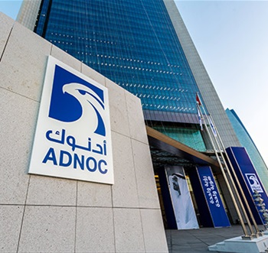](https://www.google.com.pk/url?sa=i&url=https%3A%2F%2Fwww.adnoc.ae%2Fen%2Fnews-and-media%2Fpress-releases%2F2019%2Fadnoc-named-middle-easts-most-valuable-brand&psig=AOvVaw2JDvc8D9mqJ8th7OkjmyRb&ust=1581370327647000&source=images&cd=vfe&ved=0CAIQjRxqFwoTCLDGzdm1xecCFQAAAAAdAAAAABAD)

Such stereotypes of the Middle East are frequently misleading, however, for a geographic region that is larger and more diverse than many Westerners imagine. Nevertheless, the Arab/Muslim “worldview” is different from that which is predominant in the United States, not only ideologically but also socially and economically. Starck and Kruckeberg warn that we can never fully escape our own culture in understanding other cultures (1991, Fall, p. 25). Sriramesh and White argue that cultural differences among societies must affect how public relations is practiced by people within different societies (1992, p. 597). They argue for a culture-specific approach to public relations (1992, p. 609). Certainly, it would be reasonable to question whether public relations, as it is practiced in the United States, would be acceptable and effective in the Middle East.

The complexity of this question is compounded when a Middle East country practices “international” public relations with other “Third-World” as well as with “First-World” countries. El-Enad argues that public relations’ role in the “Third World” is not between an institution and its publics, as in the West, but between the material and nonmaterial aspects of the culture (1990, Spring, pp. 24-26). A predominant consideration when applying public relations theory and its corresponding strategies, tactics and techniques, especially in the “Third World,” must be such regions’ indigenous cultures. Such consideration begs the ultimate question of “universality” versus “relativism” of public relations theory and its corresponding strategies, tactics and techniques in different societies, all of which are invariably culture-bound. This case study describes how a Middle East oil company used an international special event to communicate its story to a global audience.

**Strategic Tactics and Techniques**

ADNOC Group of Companies’ delegation to the IPPE ‘97 was headed by Mr. Hulaiman Al Hamly, ADNOC’s Public Relations Division manager. The Group sponsored an extensive exhibit that featured logos of subsidiary companies such as Abu Dhabi Gas Liquefaction Ltd. (ADGAS), Abu Dhabi Gas Industries, Ltd. (GASCO) and ADCO, in addition to ADNOC’s main logo. Processing and Marketing Directorates staff participated in the event, together with representatives from ADGAS, ADCO, Abu Dhabi National Oil Company (ADNOC-FOD) and Ruwais Teitilyeu Industries (FERTIL).

ADNOC Group staff promoted the company’s high-quality, award-winning products. These staff members briefed visitors on the UAE’s business environment and on opportunities that are available for international investors. The display contained printed materials on the ADNOC Group of Companies and their petrochemical products, compact disc-based databases and data-show presentations. The United Arab Emirates ambassador to China as well as the UAE delegation to the World Petroleum Congress were present at the exhibition.

**Results Achieved**

Company sources said the ADNOC Group exhibit attracted a large number of visitors. They included dignitaries such as: the ambassadors of the United Arab Emirates, Kuwait, Oman and Belgium; the Chinese Vice Premier; official delegates who were participating in the World Petroleum Congress; and members of the Chinese and Asian business communities. Upon his visit to the ADNOC exhibit, the Chinese Vice Premier was honored with a symbolic gift that was presented to him by the UAE ambassador to China.

“The China exhibition was one of the most important events to be staged in East Asia,” said Shukri Al-Haddad of ADNOC-FOD. “The ADNOC Group’s participation in that fair proved to be successful and attracted interest from various representatives of oil and gas companies” (Staff Talk About Their Experiences in China, 1997, November, pp. 1, 3).

Jamal Al Awartani, another member of the UAE team who participated in the fair, said, “All visitors had shown great interest in our products and services, and this reflects the important role the ADNOC Group plays in world oil and gas markets” (Ibid.). Nasser Al Jassmi of ADGAS noted that his company’s participation in the event had given it an extra incentive to closely observe the Chinese market. He added that the exhibition had proven to be a success, considering the large number of companies that had participated in it (Ibid.).

1. **Public Relations in Bosnia**

**The Problem**

This case study is based on the author’s experience as a U.S. Air Force officer, who deployed to the Former Yugoslavia in the winter of 1995 as part of the Implementation Forces’ (IFOR) public relations team. As the first chief of IFOR’s Internal Information division the author’s challenge was to form an international team, to recruit members and to develop strategies and tactics for a new program involving several countries. The resulting internal information program produced the IFOR Informer, a newspaper for the 60,000 troops temporarily stationed in Bosnia, Croatia, and Hungary.

[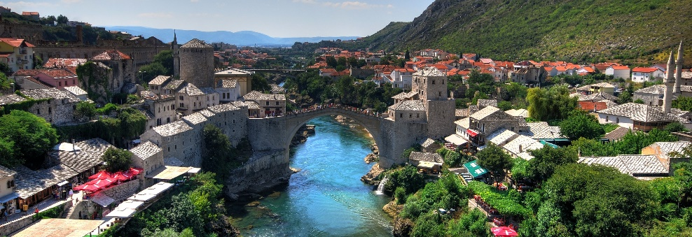](https://www.google.com.pk/url?sa=i&url=https%3A%2F%2Fwww.nhc.no%2Fen%2Fbosnia-herzegovina%2F&psig=AOvVaw2-3tNnc-vSMWor1u9VEU_T&ust=1581370477586000&source=images&cd=vfe&ved=0CAIQjRxqFwoTCKDcp6C2xecCFQAAAAAdAAAAABAD)

**Strategic Goals and Objectives**

If you don’t have a plan, then you plan to fail. The campaign chief had written plans for conducting public relations during war, but now had to develop a plan for conducting a peacekeeping mission with former adversaries serving on the same side. A plan was drafted that took into consideration how broadcast needs would be met, what equipment would be needed to produce a newspaper, the most advantageous place to publish the newspaper and the staffing required for the newspaper.

Once the plan was approved, a contract was written that complied with Italian law for the Naples publisher. The contract stated: 15,000 copies would be published biweekly for six months with a renewable option. The newspaper would be two colors with an option for four-color separations. Each issue would be printed in English and French, the official languages of NATO.

Strategic planning documents were modified to reflect the requirements of the new internal information program. Strategic goals established for the IFOR Informer were:

* To provide an avenue for the commanders to communicate with their troops, through articles and editorials

* For the troops to learn about other units and the countries they represented

* To entertain the troops

* To provide valid information of interest to IFOR for the duration of the mission

The tactical plan or the actual execution of the strategic goals hinged on how well internal communication worked, not just through the newspaper. Even when there is a common language, the communication process is convoluted, at best. For the multinational IFOR staff, it was even more difficult.

**Results Achieved**

The legacy of the IFOR Informer continued as long as the IFOR mission. After 1997 the IFOR military forces in Bosnia became the Stabilization Forces (SFOR). With this change, the newspaper no longer had a place except in the history of IFOR.

Although there are many scientific ways to measure the success of a program or a specific aspect of it, perhaps the hearsay comment of Admiral Smith sums it up best. He is quoted as having said he was so pleased that he insisted on having a successor of the IFOR Informer for the SFOR.

IFOR’s PLO established a model for multicultural public relations in every definition of the term. From the multicultural staff to the multicultural publics, this operation established the identity of IFOR in the hearts and minds of the troops, the countries where they were stationed and the world.

Although IFOR is not a corporation, it did develop a “corporate image” in the international arena. In the history books, IFOR will be remembered for what it did--maintaining peace in a volatile, war-torn country. This was the image COMIFOR wanted to portray and is indicative of how future successes will be measured.

In addition to building new tools in a multicultural environment, the IFOR internal information team developed policy and procedures for successors to use. Because there were similarities in how varied cultures viewed public relations, the strategic plans could be similar even though the tactics of accomplishing the goals varied. Cultural differences contributed to a more diverse approach to reaching goals, and demanded a broader approach than the tunnel vision approach of the “America knows best” attitude.

The measurement of success can be found in the completion of a task. After a month of research, planning, and communicating, the first newspaper rolled off the presses and was distributed throughout the region After the first two issues, many of the troops surveyed said they eagerly looked for the IFOR Informer. The newspaper was a tool for communicating with the troops, but it became a souvenir for many of those serving their time in Bosnia. It was a way of remembering their part in a special mission and of bringing cohesiveness to a diverse organization.

**References**

Staff report, “Bosch Warned VW about Illegal Software Use in Diesel Cars, Report Says,” Automotive News Europe, September 27, 2015, accessed December 16, 2015, http://europe.autonews.com/article/20150927/ANE/150929837/boschwarned-vw-about-illegal-software-use-in-diesel-cars-report-says.

Volkswagen, TDI: U.S. Market Success, March 2015, accessed December 16, 2015, http://cleandieseldelivers.com/media/Douglas-Skorupski-VWoA_DTF_March2015.pdf.

Jeff S. Bartlett, “Making Sense of the Volkswagen Diesel Mess,” Consumer Reports, September 28, 2015, accessed December 16 2015, [www.consumerreports.org/cro/cars/making-sense-of-the-volkswagen-diesel-mess](http://www.consumerreports.org/cro/cars/making-sense-of-the-volkswagen-diesel-mess).

Matthew Debord, “If VW Deceived Consumers about Its Diesel Cars, Then It Has a Huge Problem,” Business Insider (India), September 19, 2015, accessed December 26, 2015, www.businessinsider.in/If-VW-deceived-consumers-about-its-dieselcars-then-it-has-a-huge-problem/articleshow/49027651.cms.

Jad Mouawad and Sydney Ember, “Emissions Scam: How Volkswagen’s Diesel Pitch in US Relied on Fun and Fantasy,” The Economic Times, September 28, 2015, accessed December 16, 2015, http://articles.economictimes.indiatimes.com/2015-09-28/news/66957753_1_diesel-car-vw-passat-tdi-new-car. 14 Ibid.

Tyler Durden, “Volkswagen: A Decade of Deception—Full Chronology,” Zero Hedge, October 2, 2015, accessed December 28, 2015, www.zerohedge.com/news/2015-10-02/volkswagen-decade-deception-full-chronology. 16 Jim Gorzelany, “Automakers with the Lowest (and Highest) Recall Rates,” Forbes, March 26, 2014, accessed January 16, 2016, [www.forbes.com/sites/jimgorzelany/2014/03/26/automakers-with-the-lowest-and-highest-recall-rates/](http://www.forbes.com/sites/jimgorzelany/2014/03/26/automakers-with-the-lowest-and-highest-recall-rates/).

BOBSTOCK, P, 1985, ”Johnson & Johnson: Tylenol”, in Denig, E, Van Meiden, A (ed), A Geography of Public Relations Trends, Dordrecht-Boston, Martinus Nijhoff Publ.

FINK, Steven, 1986, Crisis Management: Planing for the Inevitable, New York, Amacom.

PINSDORF, M., 1987, Communicating When Your Company Is Under Siege, Massachussetts, Lexington Books, 1987.

<https://wolfe.com.br/en/2018/07/14/suspected-corporate-killing-shareholder-dispute-mismanagement-suspicious-death-crisis-management/>

<https://wolfe.com.br/en/2018/06/14/corruption-scam-involving-bank-executives-payment-of-kickbacks-graft-diversion-of-funds-money-laundering-crisis-management/>

Eighty Regional and International Airlines and 112 Airports Use Dubai Airport. (1996, March 21). Al Bayan Daily (Dubai), p. 4.

1.6 Million Guests in Dubai’s Hotels Bring $ 400 Million Last Year. (1996, September 21). Al Hyatt Daily (London), p. 14.

Shopping Festival: 122 events and Dhs. 70 million prizes. (1997, March 21). AlKhaleej Daily (Shaxjah), p. 31.

World Tourism Revenues Reach $ 404 Billion Last Year. (1997, May 23). Al Khaleej Daily(Sharjah), p. 29.

Author. (1996, November 16). Al Eqtisadi Weekly.

Trade and Industry. (1996, February). Dubai: Dubai Chamber of Commerce.

<file:///C:/Users/PC/Desktop/MPhil%20Mass%20Communication/15CaseStudies%20(1).pdf>